

CSE302 (Section 1)
[Summer 2022]

Lab Assignment Submission Report

Assignment Title: Lab tasks of LAB03

Submitted by:
Aisha Siddika Mim
2020-1-60-040

1. Screenshots

LAB TASK 01:

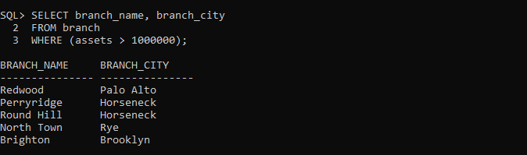

LAB TASK 02:

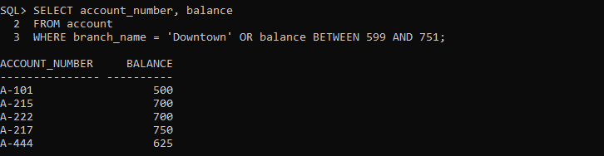

LAB TASK 03:

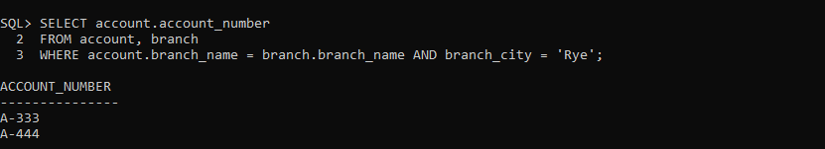\

LAB TASK 04:

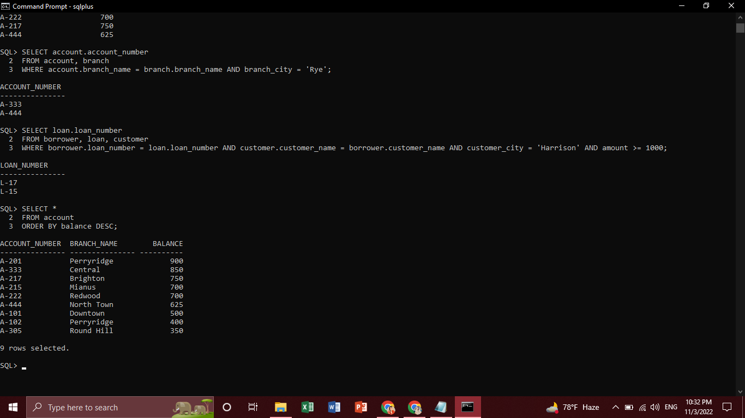

LAB TASK 05:

LAB TASK 06:

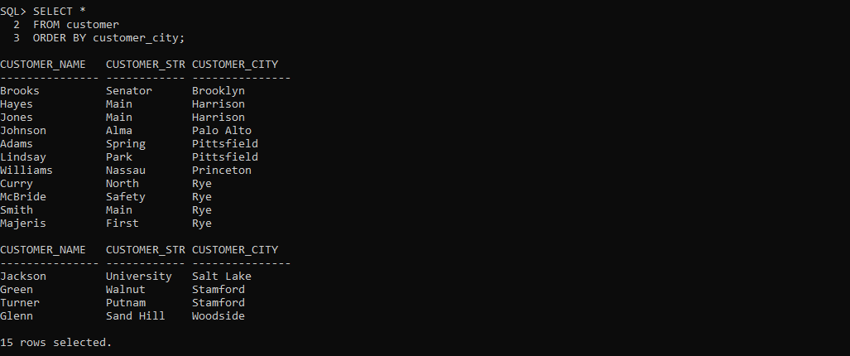

LAB TASK 07:

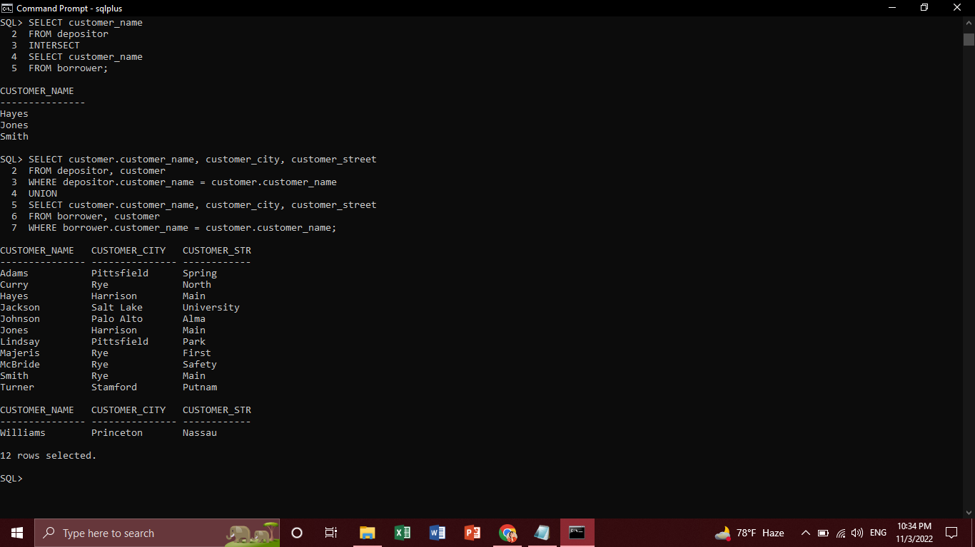

LAB TASK 08:

LAB TASK 09:

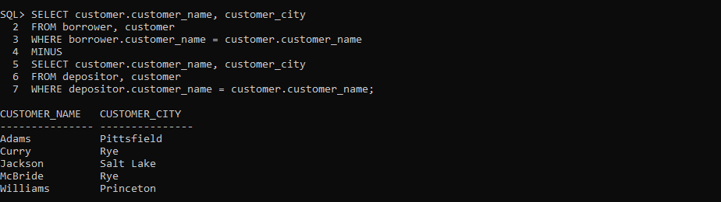
LAB TASK 10:

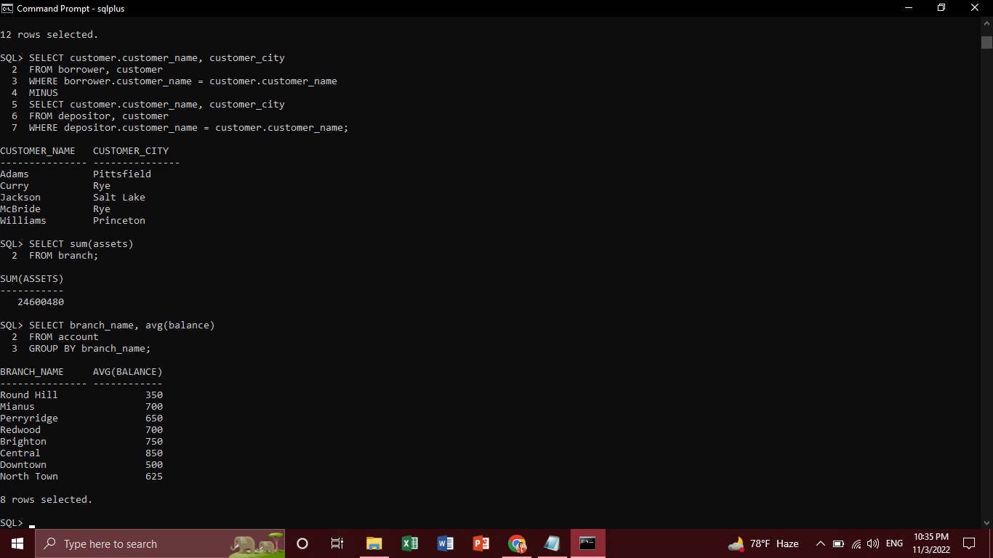

LAB TASK 11:

LAB TASK 12:

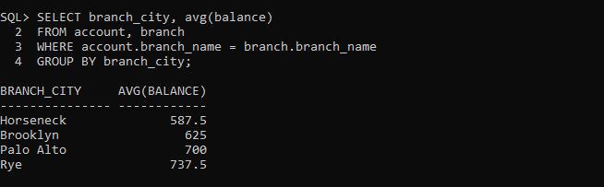

LAB TASK 13:

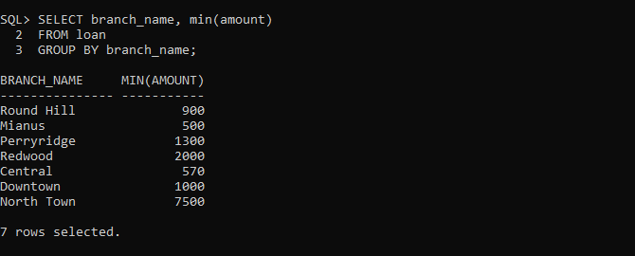

LAB TASK 14:

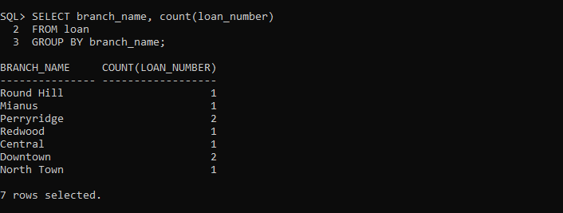

2. Learning Outcomes

From this lab, I have learned about aggregate functions and practised set relations, multiple table and single table queries.

